BROWARD COUNTY BOARD OF COUNTY COMMISSIONERS
MUNICIPALITIES CDBG APPLICATION

Complete the following sections. Submit one form for each project. Attach additional pages as needed
COMMUNITY DEVELOPMENT GRANT PROJECT SUMMARY

Category Budget
Cash
In-Kind
Other Grants

CDBG
TOTAL

PROGRAM ACTIVITIES: NATIONAL OBJECTIVE
Only one category per application

Public Service (15% Cap) ( ) Limited Clientele ( )
Capital Improvement ( ) Limited Clientele ( )
Capital Improvement ( X ) Area Benefit ( X )
Housing ( ) Low/Mod Housing (LMH) ( )
Capital Improvement ( ) Area Benefit ( )
Economic Development ( ) Low/Mod Jobs (LMJ) ( )
Continuing Project: Yes ( )
New Project: Yes (X )
DUNS NUMBER:

Applicant completes the following items.
1. Applicant Organization Name: City of Dania Beach

Address: 100 W Dania Beach Blvd.

Telephone #: 954-924-6805 X3643 FAX #: 954-922-2687

2. Contact Person: Marc LaFerrier

Title: Director, Community Development Department

Street Address: 100 W Dania Beach Blvd.

E-MAIL Address: mlaferrier@ci.dania-beach.fl.us

Telephone #: 954-924-6805 X3643 FAX #: 954-922-2687

3. Project Name: Oasis Neighborhood Improvement Project
4. CDBG Funds Requested ($15,000 Minimum Request): $149,326

5. Project Goals: Provide specific project goals and quantifiable objectives. Quantifiable objectives should specifically state who, what, where and how many. The scope of services must include activities involved in implementing the project. Project continuation and maintenance relates to the whether or not this will be an ongoing activity after funding ends.

a. Project Goals and Quantifiable Objectives: Describe how goals and objectives will either: 1). benefit low income persons, 2). provide an area benefit: 3). eliminate or prevent slums and blighted conditions, or 4). impact a problem or need of particular urgency. Only pick one of these objectives. (Please note that HUD requires that 70% of CDBG funds must benefit low/moderate income persons over a three year period).

The proposed Solar Lighting Project will provide an area benefit to low/mod neighborhoods. The Solar Lighting program is a citywide improvement initiative which includes Solar Lights placed in City Parks, City properties and along public rights-of-way with the intent to promote crime prevention, public safety and to reduce blight. The proposed project will be located within CDBG eligible census block groups and within the Community Redevelopment Agency boundary. Due to the success of the previous solar lighting projects, the City desires to expand this project throughout the CDBG eligible areas.

b. Detailed Scope of Services: The scope of services should explain exactly what will be accomplished with the funds requested.

The City is designating all neighborhoods in the CRA (map attached) and other CDBG eligible areas for funding. The areas where improvements will be made are low/mod neighborhoods that will be improved upgrades to public infrastructure. The project is an extension of efforts to improve visual appeal, public safety to neighborhoods and encourage civic pride, enhance crime prevention, increase property values and improve living conditions.

c. Project Continuation and Maintenance: Indicate what organization is responsible for maintenance of the project after completion. (Attach letters or verification).

All upgrades to public infrastructure will be made in the public right-of-way and City properties. The Dania Beach Public Services Department will maintain solar lights that are installed with CDBG funds.

d. Program Design: How do you plan to achieve the goals identified above. Please be clear and specific.

The City is conducting a downtown asset inventory. The downtown leads to neighborhoods adjacent to the downtown. As a result the City will follow this protocol based on results and coordination with the downtown assessment:

- Identify areas which will require identifying the street(s) and areas that will have the greatest impact in meeting the City’s neighborhood improvement goals by weighing the need for planned improvements and available funding.
- Using students at Florida Atlantic University, a concept will be created for each affected property and right-of-way. The proposed improvements will be mapped for City and Broward County review and inspection.
- Engineering plans will be developed based on the results of the City’s review of step 2
- Neighborhood Meeting – The city will use the plans developed in Step 3 to invite the residents in the affected community to a community meeting to get feedback on the proposed improvements and identify any neighborhood preferences. Staff will discuss the proposed improvements with the residents at the meeting.
- Based on the results of steps 3 and 4, the City will develop a final budget and adjust as needed based on funding availability
- Finalize Bid package
- Bid project – project will be bid through the City Clerk’s office and consultant
- Construction – construction management will be performed by the City and its consultants
- End of project.

6. Applicant’s Management Capability: Briefly describe the capacity of your municipality to undertake the proposed project. Discuss prior experience in the administration of Federal funds and list existing funding agreements.

a. Discuss experience in the administration of Federal funds and general management capacity, include other Broward County funded programs.

The City has only one project ongoing. All others are complete.

First Grant
Project Name | Solar Lighting | Funding Amount | $149,326
Contract Period | 41st year | Balance of funds unspent

Second Grant
Project Name |  | Funding Amount
Contract Period |  | Balance of funds unspent

Third Grant
Project Name |  | Funding Amount
Contract Period |  | Balance of funds unspent

7. Description: Describe the outcome(s) of the project. Description is to include
timeframe for start-up and completion, street location of the service and census tract(s). Describe the service area.

- Project Description: Capital improvements should state anticipated linear
feet of project or number and description of public facilities. Applicant must already have construction plans for project at time of application. Public service projects should specifically state number of

clients per year. Housing development or rehabilitation should state number of housing units. Economic development projects, should state number of businesses to be assisted, jobs created and describe loans available. Both Rehabilitation and New Housing Construction should comply with Energy Star Requirements.

The project involves the installation approximately 20 solar lights, within the CRA neighborhood.

b. Time Frame: What is the time frame for start-up and completion after notification of funding award? Indicate what funding commitment is required to provide for timely project start-up.

Project will be complete by September 30, 2016.

c. Street address / Location: Attach map identifying both census tracts and project location. Also provide a street address or a description of the location when site acquisition is involved. Provide current Phase 1 – Environmental Assessment and NEPA Environmental Assessment Checklist for Capital, New Construction and Economic Development activities that were done within 6 months of application for funding.

See attached map of area. ESA not required

d. Census Tract(s) and Block Groups: Consult census maps for the census
tract location of this project. (Area benefit projects must serve 51% low
and very low income persons.)

See attached map of Affected Census Tracts

8. Proposed activities located in the Community Redevelopment Area (CRA), must
provide a copy of the area’s CRA Plan and map (attached) in order to be considered eligible under a HUD Slum/Blight designation. The following information must be provided at the time of application:

a. Percentage of Deteriorated buildings See attached CRA plan
b. Year area designated Slum/Blight See attached CRA plan
c. Description of Slum/Blight area See attached CRA plan

9. Budget Table Instructions: Complete the following Budget Table and
provide the requested information on the matching share of resources committed to the project.

a. Budget Table: For each expenditure category, (Personnel, Benefits, Travel, Equipment, Supplies, etc) enter the proposed amount necessary for that category. Please list these amounts according to the appropriate funding source as shown in the shaded area.

Category | CDBG | Non CDBG | Non CDBG | TOTAL All Sources
Personnel
Benefits
Travel
Training
Equipment
Supplies
Contractual With Outside Agencies or Vendors |  |  |  | 5,500
Construction | 149,326 |  |  | 149,326
Other
Totals | 149,326 |  |  | 154,826

10. Budget Narrative Instructions: The budget narrative statement should provide a detailed explanation and justification for each cost category shown in the Budget Table on page 5. The budget narrative should identify non-CDBG resources to be utilized in financing the project, including mortgages or construction financing for the project. Also, specify the costs for which CDBG funding is being requested and the costs to be covered by non-CDBG resources. Additional pages can be added, if necessary.

11. Describe and calculate Leveraging: Describe and attach supporting documentation including letter(s) of commitment, resolutions, minutes of meetings, etc., showing specific resources the applicant will commit to the project as identified in columns 2 and 3 of the Budget Table on page 6. Include and identify in-kind contributions, sweat equity and other resources.

n/a

a. Provide documentation as an attachment and summarize below.

- For economic development projects, the value of the jobs produced in the previous year can be used as leverage. Documentation must be provided showing name of business, job title and salary.

2. For housing development projects, anticipated mortgage financing will be considered as in-kind contribution.

b. Instructions on calculating leveraging

Leveraging will be computed by taking into account the total dollar cost of the entire project including in-kind contribution.

Percent Leveraging = Total Non-CDBG Funds $ X 100

Total CDBG $

In computing Total Cost of the project, funding from all sources for the project must be added. This includes Federal funds, State funds, contributions, private sector financing, in-kind contributions, etc.

In-Kind Contributions are non-cash items. Non-cash items are

contributions to the project, e.g., labor, office space, use of equipment, etc that do not involve cash payments by the entity. However, a dollar value must be provided for in-kind contributions and that value must be added to the cost of the project. In-kind contributions must be accounted for and included in the financial audit of the funded entity.

Calculations:

12. The project generally reflects adopted plans, goals, objectives and policies.

a. Project consistent with Broward County Consolidated Plan: Project should explain which Consolidated Plan priority it will address.

Meets goals to address community redevelopment, reduce blight and improve neighborhoods.

b. Project Consistent with Local Government Plans and Zoning: Project letters from municipality or County government in which the project will occur, stating consistency with county or municipal adopted comprehensive plans. Provide Flood Plan Map, if in flood plain.

N/A

c. Is project a permitted use in the zoning text regulations for the zoning district designated for the project site?

Yes [ X ] Attach municipal or County verification of zoning and adopted future land use plan designation for the site (Not applicable)
No [ ] plan of action to achieve zoning district change.

d. Plat Approval: Does your project require platting or a plat note amendment?
Yes [ ] Attach platting requirements and time table for
completion.

No [Z ] Provide Plat Name, Plat Book Number and Plat
Page Number N/A

e. Countywide Programs: If a specific program in the area of single family or rental rehabilitation, residential redevelopment, commercial revitalization, or redevelopment is proposed, explain how the program will be more effective on a cost and services basis then the same program provided by the Broward County Community Development Division.

f. State and Regional Policy Plans: The Florida State Comprehensive Plan provides long-range policy guidance for the orderly social, economic and physical growth of the state. The Strategic Regional Policy Plan for South Florida specifically addresses housing and economic development.

13. Real Property and Relocation Policy: Complete this section when displacement of families or businesses is required.

a. Real property: Does the proposed project require the acquisition, subordinated or leasing of real property?

Yes [ ] Provide a legal description, street address and the property owner’s name. Consult with Broward County Housing Finance and Community Development Division staff before acquiring real property in order to follow Uniform Acquisition Procedures.

No [ X ] No property is to be acquired

- Relocation: Does the proposed project necessitate the relocation of homeowners, tenants or commercial establishments.

Yes [ ] Outline the proposed relocation plan and show source of funds on Page 5 and 6 for the budget table and narrative above.

No [X ]

14. Citizen Participation: Complete this section for citizen participation documentation. How did the citizens in your jurisdiction participate in the selection of this project?

City Commission identified issues and ongoing community priority discussions

a. A copy of the resolution from the governing body giving authorization to submit proposal(s) with name and title of official designated to sign application.

b. Copies of meeting or hearing notices which verify efforts to invite citizen input (to include points of distribution) and pertinent information from the municipality reflecting inclusion of citizen input in final decisions. Documentation includes a copy of the certified proof of advertising of the public hearing held by the governing body.

c. Verification of other efforts which provide information to citizens, i.e., workshop notices, attendance records, sunshine ads, civic association meetings.

14. Certification: Please complete the certification below:

If this application is approved for funding, the organization agrees to comply with all required Federal, state and local laws and regulations. The organization confirms that it is fully capable of fulfilling the obligations as stated in this proposal and in any attachments or documents included with this application.

As a duly authorized representative of this organization, I submit this application to the Broward County Housing Finance and Community Development Division and verify that the information herein is true, accurate and complete.

PENALTY FOR FALSE OR FRAUDULENT STATEMENT: U.S. Code Title 18, Section 1001, provides that a fine up to $10,000 or imprisonment for a period not to exceed 5 years, or both, shall be the penalty for willful misrepresentation and the making of false fictitious statement, knowing same to be false.

Name of Organization: City of Dania Beach

Type of Organization: [ X] Municipal

City Manager _____________
(Signature) (Title) (Date)

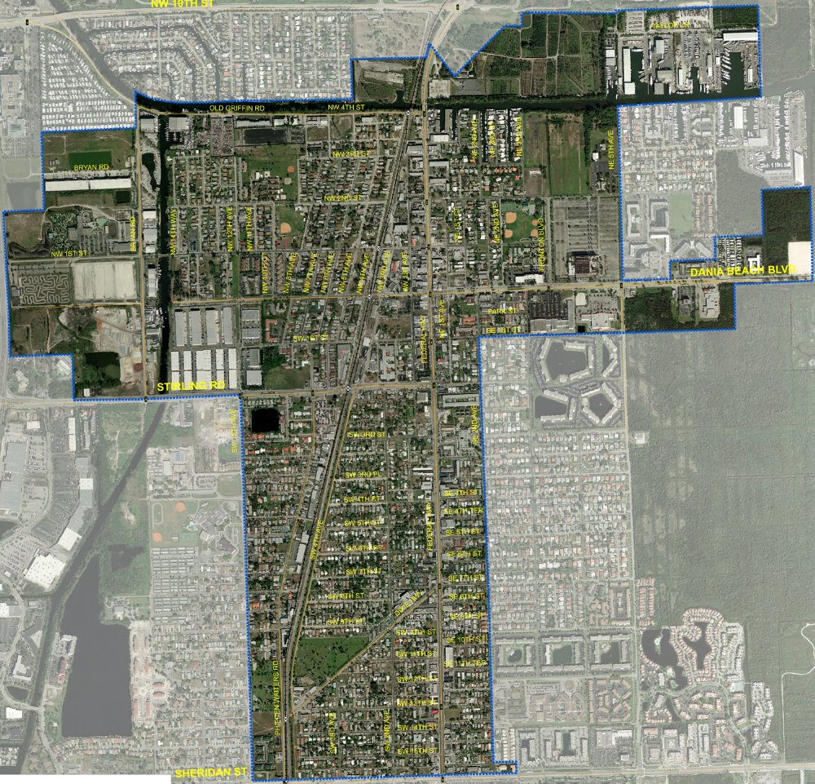

Project Area – Dania Beach CRA

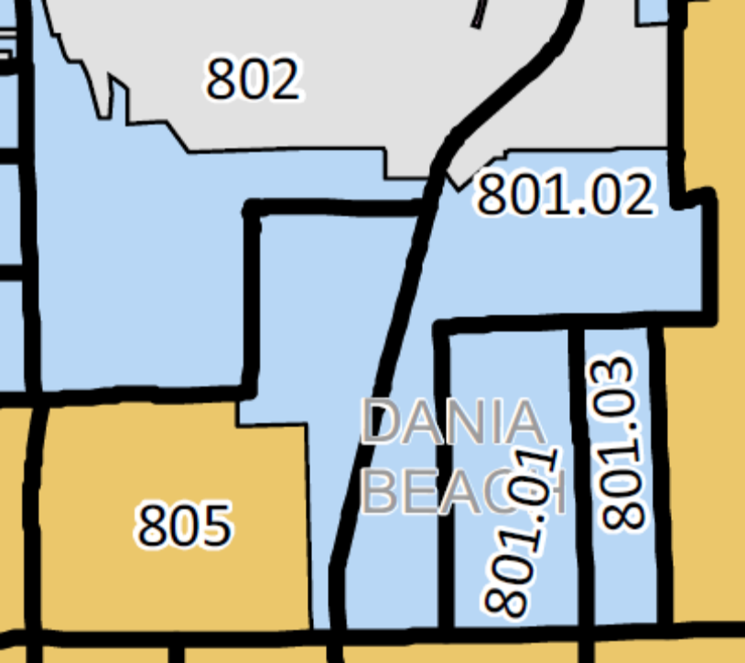

Census Tracts Affected 801.02 and 802

